MINISTRY OF EDUCATION AND SCIENCE OF THE REPUBLIC OF KAZAKHSTAN

INTERNATIONAL INFORMATION TECHNOLOGY UNIVERSITY

COMPUTER ENGINEERING AND INFORMATION SECURITY DEPARTMENT

COURSE WORK

Program with PL/SQL

Done by student: Sheri Dosbol (Lonely Tiger🐯)

Group CSSE-1809-DA

Almaty 2020

1 SUBJECT AREA DESCRIPTION

Include a short description of your subject area.

Include a relational schema of your database

# **Introduction**

This report is about designing, creating and populating a database and making queries based on it. The DB is designed to hold information relating to getting all system information of libraries and readers.

1 DESIGNING DATABASE

* 1. Subject area analysis (part 1)

1. **List entities and attributes (in other words, tables and columns of the future database). Every entity should have an unique attribute (Primary key), underline it in the description:**

There are 11 entities in the DB:

* 1. **Readers(**reader_id, reader_name, reader_surname, tel_num, address, jsn_number, ticket_id**)**
  2. **GENRE**(genre_id ,genre_name )
  3. **ROOMS**(room_id ,room_name )
  4. **AUTHORS**(author_id,author_name,author_surname,author_middle_name,nationality_id )
  5. **TICKETS**(ticket_id,ticket_name,creation_date,reader_id )
  6. **READERS**(reader_id, reader_name ,reader_surname, reader_brthd, address, tel_num, jsn_number,ticket_id )
  7. **BOOKS**(book_id,book_name, book_description,author_id,wrote_date,genre_id,
  8. quantity_page,price,quantity )
  9. **JOBS**(job_id, job_name, quantity_workers )
  10. **STAFFS**(staff_id, staff_name, staff_surname, address, tel_num, jsn_number ,job_id, staff_brthd )
  11. **DEBTORS**(debtor_id,book_id,ticket_id,room_id,order_date )
  12. **BOOKRETURNS**(b_return_id,debtor_id,return_date )
  13. **NATIONALITY**(nationality_id,nationality_name )

1. **Relationships between entities:**
   1. One reader have one ticket and in other side one ticket for one client; (1to1)
   2. One staff can work on one job and in other side in one job can be worked some staffs;(1toM)
   3. One book can have one author and in other side one author can have some books;(1toM)
   4. One rooms can have many debtors and in other side one debtor can visit one room;(1toM)
   5. One book can be enrolled only in one genre and from the other side one genre contains many books (N books); (1toM)
   6. One debtor can be one returner and other side one returner can be one debtor(1to1)
   7. One debtor can take many books and one book can be taken only one debtor(1toM)
   8. One reader have one ticket and in other side one ticket for one client; (1to1)
   9. One author can be born in one country and in other side in one country can was born many authors(1toM)
2. **Constraints:**
   * All the ID’s are unique;
   * One reader can have only one ticket;
   * Jsn number must be contains 12 digits;
   * Debtors must return books within a month;
   * Readers can`t take a book without permission of the staff;
   * Readers can`t take more than one book;
3. **Specify groups of users and their access rights:**
   1. Staffs can see information about readers but Readers can`t.
   2. Staffs can add and remove books, but Readers can`t.
4. **List potential questions from users to the database (queries):**
   1. SELECT *FROM Tickets.
   2. SELECT *FROM Jobs.
   3. INSERT *INTO Genres.
   4. DELETE *FROM Books
   5. ALTER TABLE authors DROP column nationality,

add nationality_id int references Nationality;

* 1. ER diagram (part 2)

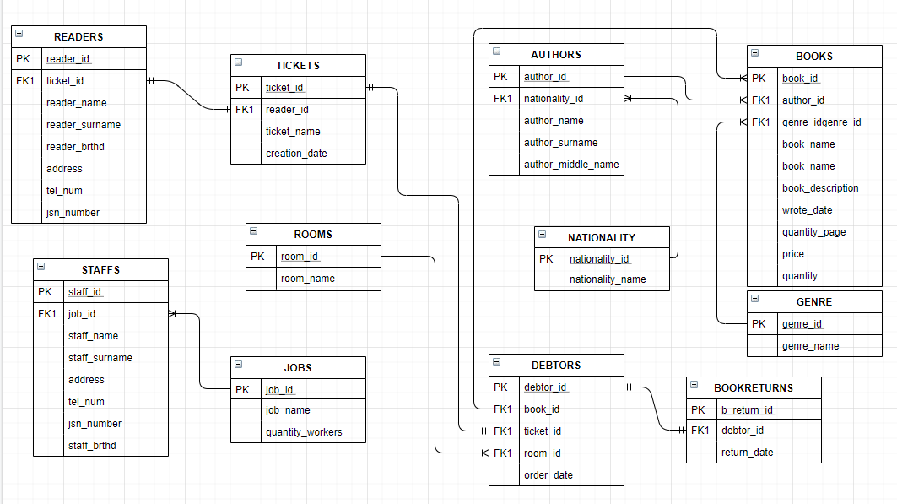

2 SQL SCRIPT FOR IMPLEMENTING THE DATABASE

2.1 Creating tables

CREATE TABLE GENRE(

genre_id INT PRIMARY KEY,

genre_name varchar (20)

);

CREATE TABLE ROOMS(

room_id INT PRIMARY KEY,

room_name varchar(20)

);

CREATE TABLE AUTHORS(

author_id INT PRIMARY KEY,

author_name varchar(20),

author_surname varchar(20),

author_middle_name varchar(20)

);

CREATE TABLE TICKETS(

ticket_id INT PRIMARY KEY,

ticket_name varchar(35),

creation_date date

);

CREATE TABLE READERS(

reader_id INT PRIMARY KEY,

reader_name varchar(11),

reader_surname varchar(11),

reader_brthd date,

address varchar(35),

tel_num varchar(11),

jsn_number varchar (12),

ticket_id int references TICKETS

);

CREATE TABLE BOOKS(

book_id INT PRIMARY KEY,

book_name varchar(50),

book_description varchar(200),

author_id int references AUTHORS,

wrote_date date,

genre_id int references GENRE,

quantity_page int,

price int,

quantity int

);

CREATE TABLE JOBS(

job_id INT PRIMARY KEY,

job_name varchar(20),

quantity_workers int

);

CREATE TABLE STAFFS(

staff_id INT PRIMARY KEY,

staff_name varchar(11),

staff_surname varchar(11),

address varchar(35),

tel_num varchar(11),

jsn_number varchar (12),

job_id int references JOBS

);

CREATE TABLE DEBTORS(

debtor_id INT PRIMARY KEY,

book_id int references BOOKS,

ticket_id int references TICKETS,

room_id int references ROOMS,

order_date date

);

CREATE TABLE BOOKRETURNS(

b_return_id INT PRIMARY KEY,

debtor_id int references DEBTORS,

return_date date

);

ALTER TABLE STAFFS

ADD staff_brthd date;

ALTER TABLE BOOKS

DROP column book_description;

Alter table Authors add nationality varchar(20);

CREATE TABLE NATIONALITY(

nationality_id int primary key,

nationality_name varchar(20)

);

ALTER TABLE authors

DROP column nationality;

ALTER TABLE authors

add nationality_id int references Nationality;

2.2 Populating tables

insert into genre values (1, 'novel');

insert into genre values (2, 'historical');

insert into genre values (3, 'detective');

insert into genre values (4, 'fantasy');

insert into genre values (5, 'fairy tale');

insert into genre values (6, 'lyrical');

insert into genre values (7, 'adventure');

select * from genre;

insert into nationality values (1, 'Kazakh');

insert into nationality values (2, 'Russian');

insert into nationality values (3, 'English');

insert into nationality values (4, 'French');

insert into nationality values (5, 'Chinese');

insert into nationality values (6, 'Greek');

insert into nationality values (7, 'British');

delete from nationality where nationality_id=5;

select * from nationality;

insert into AUTHORS values (1, 'Mukhtar', 'Auezov', 'Omarkhanuly', 1);

insert into AUTHORS values (2, 'Lev', 'Tolstoi', 'Nikolaevich', 2);

insert into AUTHORS values (3, 'William', 'Folkner', '', 3);

insert into AUTHORS values (4, 'Homer', '', '', 6);

insert into AUTHORS values (5, 'Artur', 'Konan', 'Doila', 7);

insert into AUTHORS values (6, 'Dosbol', 'Sheri', 'Sabituly', 1);

select * from authors;

insert into Books values (1,'War and World', 1,date '1942-09-25', 1, 870, 2000, 3);

insert into Books values (2,'Shum and Yarost', 3, date'1863-02-24', 1, 1300, 3000, 2);

insert into Books values (3,'War and World', 2, date'1863-02-27', 1, 1274, 2000, 3);

insert into Books values (4,'Sherlok Holmes', 5,date '1891-02-27', 3, 1500, 3500, 3);

insert into Books values (5,'In The Dream', 6,date '2000-09-25', 4, 2020, 65000, 1);

insert into Books values(6,'Mahabbat, kyzyk mol zhyldar',6, date '2000-09-25',(select genre_id from Genre where genre_name = 'lyrical'),1200, 5000, 3);

select *from Books;

UPDATE books SET book_name='Abay Zholy' WHERE book_id =1;

select * from Books;

insert into rooms values(1, 'Grand Hall');

insert into rooms values(2, 'Small Hall');

insert into rooms values(3, 'individual room_1');

insert into rooms values(4, 'individual room_2');

insert into rooms values(5, 'individual room_3');

insert into rooms values(6, 'Outside');

select * from rooms;

insert into jobs values(1, 'Admin', 1);

insert into jobs values(2, 'Adviser', 15);

insert into jobs values(3, 'Vahter',3);

insert into jobs values(4, 'Tehnichka', 6);

insert into jobs values(5, 'Security',10);

UPDATE jobs SET job_name='Cleaningman' WHERE job_id =4;

select * from jobs;

insert into staffs values (1, 'Berkut', '', 'Tauda', '87076674745', '121212121212',5,date'1981-01-01');

insert into staffs values (2, 'Kairat', 'Nurtas', 'Mamasynyn uiynde', '87476674745', '121212121213',2,date'1982-02-02');

insert into staffs values (3, 'Nurlan', 'Espanov', 'Kempirlerdin qasynda', '87086674745', '141212121212',4,date'1984-03-03');

insert into staffs values (4, 'Toregali', 'Toreali', 'kiyz uide', '87026674745', '151512121212',3,date'1985-04-04');

select * from staffs;

insert into tickets values (1,'num:1', date'2020-03-18');

insert into tickets values (2,'num:2', date'2020-02-18');

insert into tickets values (3,'num:3', date'2020-03-15');

insert into tickets values (4,'neogranichennyi', date'2020-03-29');

select *from tickets;

insert into readers values (1, 'qsqqsqs', 'dsfsf', date'1981-01-01', 'Jerdin bir jerinde','87076674745','00008888444', 1);

insert into readers values (2, 'Kairat', 'Nurtas', date'1982-02-02', 'Mamasynyn uiynde', '87476674745', '121212121213',2);

insert into readers values (3, 'Nurlan', 'Espanov',date'1983-03-03', 'Kempirlerdin qasynda', '87086674745', '141212121212',4);

insert into readers values (4, 'Toregali', 'Toreali',date'1984-04-04', 'kiyz uide', '87026674745', '151512121212',3);

select *from readers;

Alter table tickets add reader_id int references readers;

UPDATE tickets SET reader_id=1 WHERE ticket_id =1;

UPDATE tickets SET reader_id=2 WHERE ticket_id =2;

UPDATE tickets SET reader_id=4 WHERE ticket_id =3;

UPDATE tickets SET reader_id=3 WHERE ticket_id =4;

select *from tickets;

update readers set ticket_id=1 where reader_id=1;

insert into debtors values(1,2,3,4,date'2020-05-25');

insert into debtors values(2,4,1,3,date'2020-05-25');

insert into debtors values(3,2,2,4,date'2020-05-25');

insert into debtors values(4,2,4,6,date'2020-05-25');

select *from debtors;

insert into bookreturns values(1,2,date'2020-09-25');

insert into bookreturns values(2,4,date'2020-09-25');

select *from bookreturns;

2.3 Functions

It is a small function which entered number and output book_name where id equal to this number;

create or replace function get_title

(b_id in books.book_id%type)

return books.book_name%type

is

b_name books.book_name%type;

begin

select book_name into b_name from books

where book_id=b_id;

RETURN b_name;

EXCEPTION

WHEN no_data_found THEN

RETURN ('Book whith id=' ||b_id ||' doesn`t exist' );

WHEN others THEN

RETURN ('Error!');

end get_title;

declare

b_name books.book_name%type;

begin

b_name:=get_title(9);

dbms_output.put_line(b_name);

end;

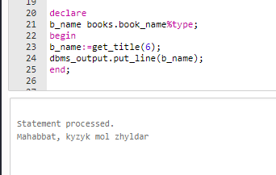

2) This function entered two numbesr id and count of books then output total price of books;

CREATE OR REPLACE FUNCTION book_price(b_id IN books.book_id%TYPE, bcount int)

RETURN books.price%TYPE

is

all_price books.price%TYPE;

bprice books.price%TYPE;

BEGIN

SELECT price INTO bprice FROM books WHERE book_id=b_id;

all_price:=bprice * bcount;

RETURN all_price;

EXCEPTION

WHEN no_data_found THEN

return 0;

END book_price;

DECLARE

all_price books.price%type;

b_id books.book_id%type:=9;

BEGIN

all_price:=book_price(b_id,5);

if all_price = 0 then

DBMS_OUTPUT.PUT_LINE('Book whith id=' ||b_id ||' doesn`t exist' );

else

dbms_output.put_line('Total price of '|| all_price ||'$');

end if;

END;

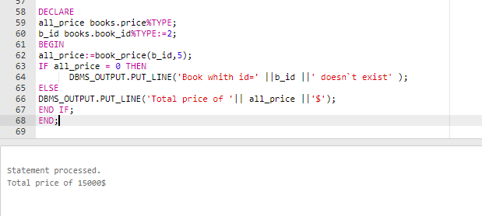

3) Fuction for finding books by authors

CREATE OR REPLACE FUNCTION get_book(a_surname authors.author_surname%TYPE)

RETURN books.book_name%type

IS

id_a authors.author_id%type;

a_book books.book_name%type;

BEGIN

SELECT author_id into id_a FROM authors where author_surname=a_surname;

for bb in (SELECT book_name FROM books WHERE author_id = id_a)

loop

DBMS_OUTPUT.PUT_LINE(a_surname || '`s book: ' || bb.book_name);

end loop;

RETURN a_book ;

END get_book;

DECLARE

a_book books.book_name%TYPE;

BEGIN

a_book := get_book('Sheri');

END;

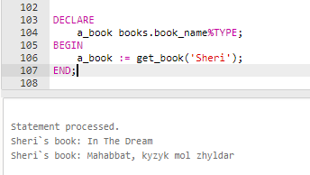

2.4 Procedures

This procedure output Author`s information about the book , When he wrote it and the title of book.

CREATE OR REPLACE PROCEDURE GET_ALL_INFO(

a_id IN authors.author_id%type

)IS

a_name authors.author_name%type;

BEGIN

SELECT author_surname INTO a_name FROM authors WHERE author_id=a_id;

FOR book IN (SELECT book_name, wrote_date FROM books WHERE author_id = a_id)

LOOP

DBMS_OUTPUT.PUT_LINE(a_name||' wrote '|| book.book_name || ' in ' || book.wrote_date);

END LOOP;

EXCEPTION

WHEN NO_DATA_FOUND THEN

DBMS_OUTPUT.PUT_LINE('There is no Author with id ' || a_id);

END GET_ALL_INFO;

EXECUTE GET_ALL_INFO(1);



2) this procedure which insert into Authors which born in UK

CREATE OR REPLACE PROCEDURE ADD_BRITISH_WRITER(

a_id authors.author_id%type,

a_name authors.author_name%type,

a_surname authors.author_surname%type,

a_mid authors.author_middle_name%type

)IS

BEGIN

INSERT INTO authors values (a_id,a_name,a_surname,a_mid,7);

EXCEPTION

WHEN DUP_VAL_ON_INDEX THEN

DBMS_OUTPUT.PUT_LINE('this id already exist: ' || a_id);

END ADD_BRITISH_WRITER;

EXECUTE ADD_BRITISH_WRITER(8,'William', 'Shakespear','');

SELECT * FROM AUTHORS;

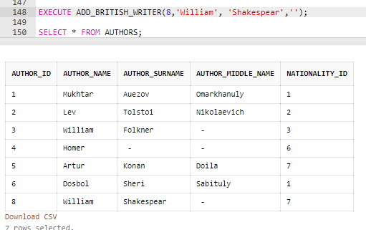

2.5 Triggers

This trigger come out when nationality which deleted has child

CREATE OR REPLACE TRIGGER before_delete_NAT

BEFORE DELETE ON nationality

FOR EACH ROW

BEGIN

FOR nat IN (SELECT nationality_id FROM authors)

LOOP

IF :OLD.nationality_id = nat.nationality_id THEN

-- nn nationality.nationality_name%type:=nationality.nationality_name;

RAISE_APPLICATION_ERROR(-20500, 'this nationality has a child');

ELSE

DBMS_OUTPUT.PUT_LINE('SMELO BRAT!');

END IF;

END LOOP;

END;

DELETE FROM nationality Where nationality_id = 2;

2) This trigger check price of books

CREATE OR REPLACE TRIGGER before_update_insert

BEFORE UPDATE OR INSERT ON books

FOR EACH ROW

DECLARE

BEGIN

IF UPDATING THEN

IF :NEW.price > 10000 THEN

RAISE_APPLICATION_ERROR(-20500, 'You entered very high price!’);

END IF;

IF :NEW.price = :OLD.price THEN

RAISE_APPLICATION_ERROR(-20500, 'You try to write same price');

END IF;

END IF;

IF INSERTING THEN

IF :NEW.price > 10000 THEN

RAISE_APPLICATION_ERROR(-20500, 'Price should be small than 10000tg. Ato kalta kotermidy');

END IF;

END IF;

END;

Update books SET price=11111 WHERE book_id=3

select * from books

select * from nationality

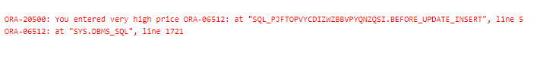

3) This trigger output message after some activity of staffs

CREATE OR REPLACE TRIGGER trigger_stf

BEFORE INSERT OR UPDATE OR DELETE ON staffs

FOR EACH ROW

DECLARE

BEGIN

IF DELETING THEN

DBMS_OUTPUT.PUT_LINE('The employee with id ' || :OLD.staff_id || ' ' || 'is deleted');

END IF;

IF INSERTING THEN

DBMS_OUTPUT.PUT_LINE('The employee with id ' || :NEW.staff_id || ' ' || 'is inserted');

END IF;

IF UPDATING THEN

DBMS_OUTPUT.PUT_LINE('The employee with id ' || :OLD.staff_id || ' ' || 'is updated');

END IF;

END;

DELETE FROM staffs WHERE staff_id = 3

UPDATE staffs

SET staff_surname = 'Pushkin'

WHERE staff_id = 2

INSERT INTO staffs VALUES (8, 'Cherepashki', 'Nindzia', 'lanalizacia', '87770009966', '151512121212',3,date'1985-04-04');

2.6 Packages

1) This package is designed to work with the table of nationalities .

CREATE OR REPLACE PACKAGE nat_pkg IS

/* A Procedure for .............*/

PROCEDURE upd_nat_name(

name nationality.nationality_name%type,

nat_id nationality.nationality_id%type );

END nat_pkg;

CREATE OR REPLACE PACKAGE BODY nat_pkg IS

FUNCTION valid_nat_id

(nat_id IN nationality.nationality_id%type)

RETURN BOOLEAN

IS

n NUMBER;

BEGIN

SELECT count(nationality_id) INTO n FROM nationality WHERE nationality_id = nat_id;

IF (n = 1) THEN

RETURN TRUE;

ELSE RETURN FALSE;

END IF;

END valid_nat_id;

PROCEDURE upd_nat_name(

name nationality.nationality_name%type,

nat_id nationality.nationality_id%type )

IS

invalid_nat_id EXCEPTION;

BEGIN

IF((valid_nat_id(nat_id)) = TRUE) THEN

UPDATE nationality SET nationality_name = name WHERE nationality_id = nat_id;

DBMS_OUTPUT.PUT_LINE('Nationalitys name with id='|| nat_id ||' was updated to ' || name);

ELSE RAISE invalid_nat_id;

END IF;

EXCEPTION

WHEN invalid_nat_id THEN

DBMS_OUTPUT.PUT_LINE('Nationality with id='|| nat_id ||' does not exist');

END upd_nat_name;

END nat_pkg;

SELECT * FROM nationality;

EXECUTE nat_pkg.upd_nat_name('Nemec', 20);

2) This package is designed to work with the table of books .

(У меня здесь была ошибка при проверке экзепшна, тот который вы проверили. ошибся с переменной 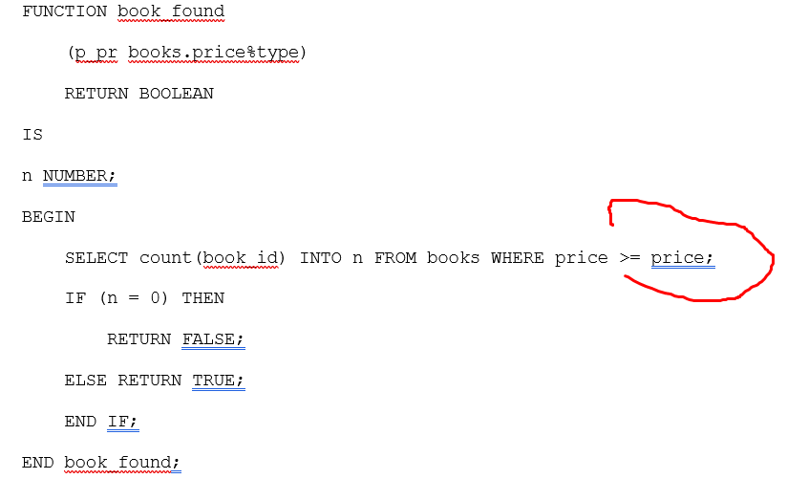  
(человеческий фактор 😊)  
)

CREATE OR REPLACE PACKAGE book_pkg IS

/* A Procedure for .............*/

PROCEDURE book_price_more_than(p_pr books.price%type);

function get_title

(b_id in books.book_id%type)

return books.book_name%type;

FUNCTION book_price_total

(b_id IN books.book_id%TYPE, bcount int)

RETURN books.price%TYPE;

END book_pkg;

CREATE OR REPLACE PACKAGE BODY book_pkg IS

FUNCTION book_found

(p_pr books.price%type)

RETURN BOOLEAN

IS

n NUMBER;

BEGIN

SELECT count(book_id) INTO n FROM books WHERE price >= p_pr;

IF (n = 0) THEN

RETURN FALSE;

ELSE RETURN TRUE;

END IF;

END book_found;

PROCEDURE book_price_more_than(p_pr books.price%type)

IS

CURSOR pr_cursor IS

SELECT book_name, price

FROM books

WHERE price >= p_pr;

not_found EXCEPTION;

BEGIN

IF (book_pkg.book_found(p_pr)=true) THEN

FOR i IN pr_cursor

LOOP

DBMS_OUTPUT.PUT_LINE(i.book_name|| ' ' || i.price);

END LOOP;

ELSE

RAISE not_found;

END IF;

EXCEPTION

WHEN not_found THEN

DBMS_OUTPUT.PUT_LINE('No BOOKS with such price');

END book_price_more_than;

function get_title

(b_id in books.book_id%type)

return books.book_name%type

is

b_name books.book_name%type;

begin

select book_name into b_name from books

where book_id=b_id;

RETURN b_name;

EXCEPTION

WHEN no_data_found THEN

RETURN ('Book whith id=' ||b_id ||' doesn`t exist' );

WHEN others THEN

RETURN ('Error!');

end get_title;

FUNCTION book_price_total(b_id IN books.book_id%TYPE, bcount int)

RETURN books.price%TYPE

is

all_price books.price%TYPE;

bprice books.price%TYPE;

BEGIN

SELECT price INTO bprice FROM books WHERE book_id=b_id;

all_price:=bprice * bcount;

RETURN all_price;

EXCEPTION

WHEN no_data_found THEN

return 0;

END book_price_total;

END book_pkg;

EXECUTE book_pkg.book_price_more_than(90000);

declare

b_name books.book_name%type;

begin

b_name:=book_pkg.get_title(6);

dbms_output.put_line(b_name);

end;

DECLARE

all_price books.price%type;

b_id books.book_id%type:=2;

BEGIN

all_price:=book_pkg.book_price_total(b_id,6);

if all_price = 0 then

DBMS_OUTPUT.PUT_LINE('Book whith id=' ||b_id ||' doesn`t exist' );

else

dbms_output.put_line('Total price of '|| all_price ||'$');

end if;

END;

SELECT * FROM books;

3) This package is designed to work with the table of authors .

CREATE OR REPLACE PACKAGE auth_pkg IS

PROCEDURE GET_ALL_INFO(a_id IN authors.author_id%type);

PROCEDURE ADD_BRITISH_WRITER(

a_id authors.author_id%type,

a_name authors.author_name%type,

a_surname authors.author_surname%type,

a_mid authors.author_middle_name%type);

END auth_pkg;

CREATE OR REPLACE PACKAGE BODY auth_pkg IS

PROCEDURE GET_ALL_INFO(

a_id IN authors.author_id%type

)IS

a_name authors.author_name%type;

BEGIN

SELECT author_surname INTO a_name FROM authors WHERE author_id=a_id;

FOR book IN (SELECT book_name, wrote_date FROM books WHERE author_id = a_id)

LOOP

DBMS_OUTPUT.PUT_LINE(a_name||' wrote '|| book.book_name || ' in ' || book.wrote_date);

END LOOP;

EXCEPTION

WHEN NO_DATA_FOUND THEN

DBMS_OUTPUT.PUT_LINE('There is no Author with id ' || a_id);

END GET_ALL_INFO;

PROCEDURE ADD_BRITISH_WRITER(

a_id authors.author_id%type,

a_name authors.author_name%type,

a_surname authors.author_surname%type,

a_mid authors.author_middle_name%type

)IS

BEGIN

INSERT INTO authors values (a_id,a_name,a_surname,a_mid,7);

EXCEPTION

WHEN DUP_VAL_ON_INDEX THEN

DBMS_OUTPUT.PUT_LINE('this id already exist: ' || a_id);

END ADD_BRITISH_WRITER;

END auth_pkg;

EXECUTE auth_pkg.GET_ALL_INFO(3);

EXECUTE auth_pkg.ADD_BRITISH_WRITER(9,'William', 'Shakespear','');

SELECT * FROM AUTHORS;